# Impact of EdTech Usability on Educator Confidence and Adaptation to Online Teaching

## 1. Abstract

## 2. Introduction

When education shifted toward online to covid pandemic, students were able to quickly adapt to online classrooms, assessments. In contrast, many lecturers who were used to traditional form of education for many years faced challenges to adapt themselves to new technologies. One major challenge was usability and accessibility of online tools. As per research, many lecturers faced difficulty in delivering lessons as effectively as traditional form of teaching, which affected the students understanding and performance [1]. Additionally, many lecturers didn’t have prior experience with online teaching tools, which made adaptation difficult. Results of another research showed that inadequate access to personal device and reliable internet this further hindered the adapted during the phase when education was shifting towards online [2].

This problem is worth discussing because education has rapidly shifted towards online during covid pandemic and it has impacted quality of teaching and learning. Although after the pandemic had ended and traditional teaching has resumed demand for online education has not decreased, as online education comes with a lot of benefits. When lecturers have lack of confidence in using online tools, it would affect the quality of learning. A study highlights that lecturer’s difficulty in adapting to online teaching tools has negatively impacted students learning and their ability to engage students [1]. Secondly, sudden requirement to adapted to online teaching has increased stress for lecturers, which indirectly affected lecturers’ performance and job and increased burnouts [2]. Although many lecturers have adapted to these platforms, investigating this problem will help in understanding the future improvements that can be made in online teaching tools.

An article in *Educational Technology Research and Development* analyzed common difficulties that stop educators from effective use of technology. It highlighted usability challenges, alongside institutional constraints and lack of professional development, limiting teachers’ ability to use online teaching tools effectively [4]. One major gap in the literature is the lack of focus on the specific design features of online teaching tools that most affect usability and adaptation. Moreover, there is limited research on how demographic factors, such as age and teaching experience, influence technology acceptance​. Research from the journal *of Educational Computing Research* studied the relationship between lecturers’ confidence and their proficiency with digital tools. It highlighted that lecturers who are trained and have access to user-friendly technology report greater comfort and are more adaptable to teaching tools [3]. However, this study does not investigate long-term impacts increased comfort on teaching performance are sustained over time.

Research questions in this study would address the gaps in studies mentioned in above paragraph and explore the usability aspects of online teaching tools and their impact on lecturers’ confidence and acceptance. Research questions for this study are:

**RQ1:** How well are lecturers adjusted to online teaching tools and their satisfaction with tools they are using?

**RQ2:** Would educators continue to use online teaching tools with new technology advancements in future?

The first research question would seek to learn the challenges in adapting to online teaching tools and would seek to know current state of adaptation and the satisfaction level, which are important for understanding broader and more sustainable effects. This second question investigates educators' behavioral intention to adopt future technological advancements in online teaching, based on their current experiences and perceptions of the technology.

## 3. Methodology

For this study lecturers from different levels of proficiency like pre-school, k-12 and higher education were chosen to understand how educators from different academic backgrounds adapted to using teaching tools. This range was chosen to check how diverse experience and challenges associated with online education across different teaching stages. Participants had minimum experience in traditional teaching for two years of experience and transitioned to online teaching due to covid-19 pandemic or technology upgrade mandated by their institution. Lecturers from different domains have been selected for this study to get understanding of teaching tools adaptation as per the subject taught. Both lecturers with and without prior experience with digital technologies were selected to compare how previous familiarity affected their adaptation process. Exclusion criteria included lecturers with extensive pre-existing experience in using online teaching tools, determined through a background history check. To reach out the participants for this survey an email method was used, and the Google survey form has been provided within the mail. Mail was also included with details like the purpose of the search and criteria used for selecting the participants, data confidentiality assurances, and instructions for completing the attached Google survey.

Technology Acceptance Model (TAM) has been used for this survey to understand the online teaching tool adaption. Based on the TAM framework questions adopted are used to measure perceived usefulness, perceived ease of use and lecturer’s intentions to continue using digital tools. The survey has been conducted using Google form which provided efficient way to collect responses from participants. Participants provided rating of agreement with various statements using Likert scale. For example, questions on perceived usefulness included items like “Using this educational technology enhances my teaching effectiveness,” while perceived ease of use was assessed with items such as “I find this platform easy to use for my teaching tasks.” Additionally, open-ended questions allowed educators to share insights about their experiences and challenges.

To operationalize the research question, I have used Technology Acceptance Model (TAM) model to convert abstract concepts into measurable variables. TAM model focuses on two factors Perceived Ease of Use and Perceived Usefulness.

For Perceived Ease of Use, I have adopted questions like “How easy was it learn and use online teaching tools”, “Do you feel comfortable using online teaching tools”, these questions are aimed to access how simple it for lecturers was to use online teaching tools and assess the mental effort to learn these tools. Each response is recorded on a 5-point Likert scale, allowing for a quantifiable measure of ease of use.

Perceived Usefulness is used to assess whether using online teaching tools has helped to complete their tasks successfully and effectively. Survey items for this construct include: “Did online teaching tools enhance the effectiveness of your teaching?” and “Did using online teaching tools help you accomplish tasks quickly?”. These questions are used to validate whether online teaching tools has positively impacted their teaching methods.

I adapted these items from Davis (1989), the author of TAM, to ensure validity and reliability. Davis’s work is widely recognized for establishing TAM as an instrument for assessing technology acceptance [5]. By using these well-established constructs, my survey captures essential aspects of lecturers’ adaptation to virtual teaching tools, while remaining aligned with established TAM literature.

The Technology Acceptance Model (TAM) best fits for this research as it specifically measures two key constructs: Perceived Ease of Use and Perceived Usefulness. These constructs align with research objective for understanding how lecturers adapted themselves to online teaching tools. TAM model has been adopted and validated across various domains of technology adoption, making it effective for assessing acceptance in educational contexts. TAM has been widely used in educational technology research to evaluate the acceptance of tools like Learning Management Tools, virtual learning environments and online learning platforms. Lecturers who are target population often encounter new technologies, this makes TAM an appropriate survey scale for evaluating how everyone perceive the ease of use and utility of such tools in enhancing their teaching performance. The TAM model is ideal for understanding the technology acceptance of lecturers because it accounts for factors influencing their willingness to use new technologies. These educators, many of whom have varying levels of experience and comfort with technology, need to feel confident in the ease of use and usefulness of the virtual tools for successful adoption. By using TAM, the survey can capture these essential factors that determine how well they adapt to virtual teaching.

The reliability and validity of TAM are well documented in academic literature. Various studies have confirmed TAM’s construct with high Cronbach's alpha scores indicating reliability in different settings, including education [5]. For example, Davis et al. [6], who initially developed TAM, reported high reliability for both Perceived Ease of Use and Perceived Usefulness. In case of educational settings, TAM has been validated by multiple studies. For instance, a study by Teo [2] showed that TAM reliably predicted the technology adoption behaviors of teachers in online teaching environments.

## 4. Results

As illustrated in Figure 1, survey included a range of educators with most (32%) having 11-20 years of teaching experience, while others had either 3-5 years (24%) or between 6-10 (28%). A smaller group, with a minimum of 2 years of experience, comprised the remaining percentage. Participants came from various proficiency levels, mainly k-12 (44%) and higher education (40%), with some from pre-schools as well. Most participants didn’t have prior training experience for online teaching tools before switching to online education, with only 44% received training. As shown in figure 2, almost all participants taught theoretical subjects and only 56.5% of participants taught practical lessons along with theoretical concepts. Class sizes varied too, with nearly half teaching classes of 20-50 students, while others managed larger or smaller groups. Interestingly, 48% of educators noted that simulations were helpful in teaching, while the rest did not find them essential. As shown in figure 3, participants are involved in teaching wide range of subjects with most participants teaching Mathematics, Science, Computer Science/ Information Technology.

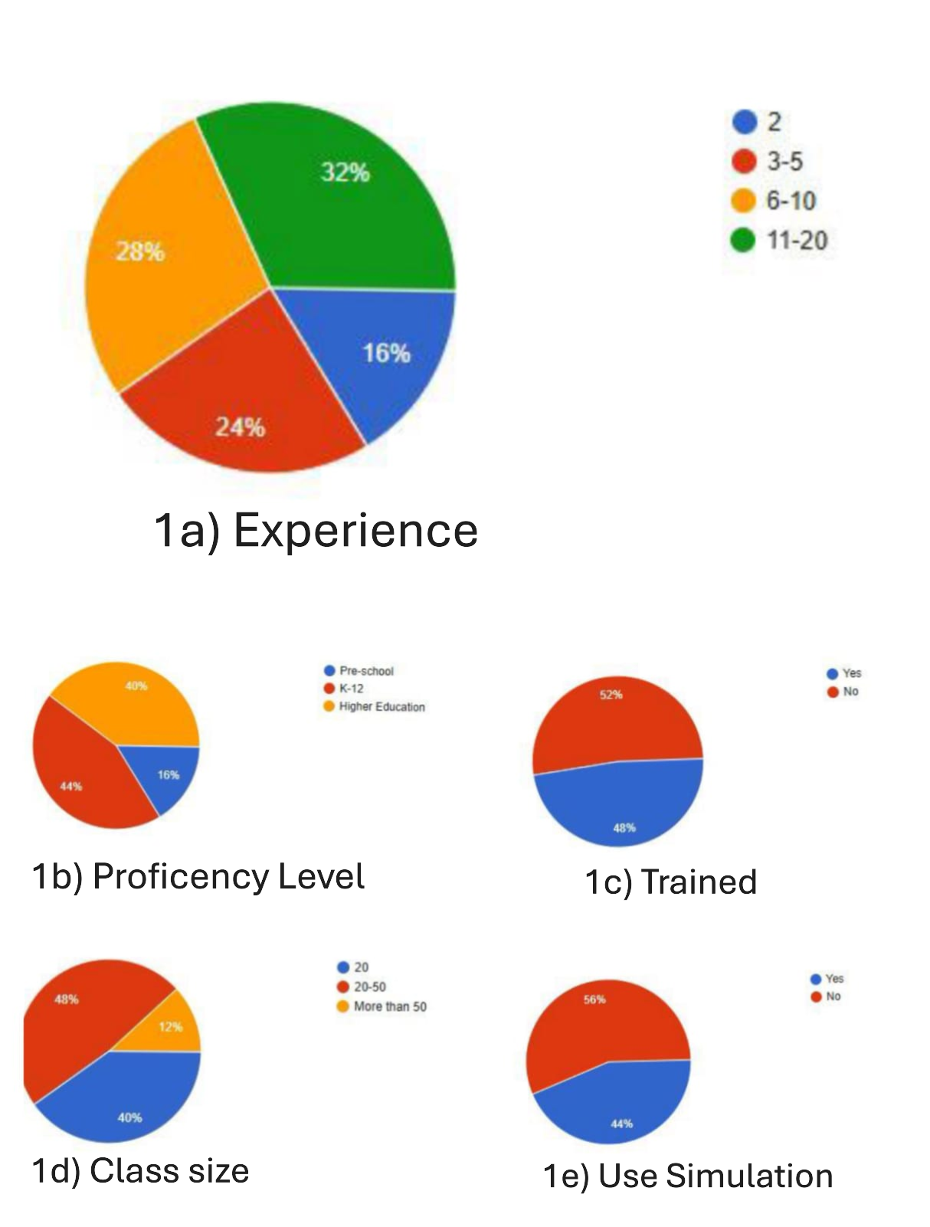

Figure 1. Demographic Pie Charts

Figure 2. Participants teaching practical concepts, theoretical concepts

The survey data offers insight in how lecturers have adjusted to different online teaching tools and their satisfaction with the resources across different demographics factors.

The analysis of online teaching tools acceptance among educator (n=25) showed serval patterns with different demographic variables. The perceived ease of use (PEOU) demonstrated moderate consistency across experience levels, ranging from mean score of 3.4 to 3.7, with novice and mid-level experience lecturers having higher scores. Perceived effectiveness (PE) showed slightly higher overall scores, ranging from mean value 3.9 to 4.3, with novice educators (2 years’ experience) reporting the highest effectiveness ratings (M=4.3). As per the level of proficiency, pre-school educators showed higher effectiveness in use of online teaching tools compared to k-12 and higher education educators, while have same ease of use across all levels of proficiency. Training emerged as a significant factor in technology acceptance, with trained educators reporting higher PEOU scores of 3.7 and marginally higher PE scores of 4.1 compared to untrained educators. Theoretical and practical concepts didn’t affect much on PEOU and PE. Similarly, the use of simulation-based teaching methods showed no significant impact on either measure, indicating that the technology's perceived value remains consistent across different pedagogical approaches.

Figure 3: Average of Constructs across various demographics

In classes with fewer than 20 students, teachers found the tools easy to use with an average score of 3.5 on perceived ease of use (PEOU) and a high average score of 4.0 on perceived usefulness (PU). Classes with 20 to 50 students had the highest scores on both aspects, with PEOU averaging 3.7 and PU reaching 4.1. This suggests that these tools might be especially good for teaching classes in this size range. However, it's interesting that larger classes (over 50 students) had similar PEOU scores to smaller classes (up to 20 students) but had the lowest PU scores among all groups. These results show that while the ease of using online teaching tools is consistent across different class sizes, the usefulness of these tools seems to slightly decrease as class sizes increase. This trend might mean that the tools are best suited for teaching classes with around 20 to 50 students, as they seem to strike a good balance between being functional and easy to manage.

## 5. Discussion

The analysis of adaptation of online teaching tools by educators highlights patterns which are like literature in education technology adoption. Firstly, training is a major factor influencing ease of use, as educators who received training in online teaching tools showed higher scores in perceived ease of use. These finding aligns with Venkatesh and Bala [7], who identified training as essential for technology adoption. Additionally, Al-Fraihat et al. [8] underscore that e-learning satisfaction increases with training, which supports the positive ratings from trained lecturers as per survey data collected.

The impact of class size on perceived ease of use (PEOU) and perceived usefulness (PU) aligns with prior studies. Sangrà et al. [9] found digital tools beneficial for engaging smaller to medium-sized classes, though larger classes face challenges in interactivity, which matches with pattern seen in data collected: with educators managing class of size 20-50 reported higher perceived effectiveness. As per experience levels, perceived effectiveness ratings were highest among novice educators, which is match with finding of Teo [10], who showed that early positive experiences often lead to long-term adoption—a trend reinforced by high ratings in ease of use and effectiveness among newer lecturers.

As per analysis, educators teaching theoretical and practical didn’t show much deviation in perceived tool utility, which is consistent with Pynoo et al. [11]. It has been observed that technology adaption is important for any subject, which suggests that tools are flexible enough for teaching both practical and theoretical concepts.

In can be inferred from results, supporting training would encourage higher acceptance of online teaching tools across all the proficiency levels. Moreover, ensuring the adaptability of online platforms to different class sizes could enhance the functionality and satisfaction educators experience with these tools.

5.1 ***How well are lecturers adjusted to online teaching tools and their satisfaction with the tools they are using?***

Lecturers reported moderate to high levels of adjustment and satisfaction with online teaching tools. Experience and training seemed to be significant factors; lecturers with training reported higher ease of use and perceived effectiveness. This suggests that while most lecturers are adapting, additional training might enhance satisfaction and adjustment levels across all experience groups.

***5.2 Would educators continue to use online teaching tools with new technology advancements in the future?***

Educators reported generally positive experiences with current tools, particularly in terms of perceived usefulness. Those who found the tools effective and adaptable were more inclined to adopt future advancements. High perceived usefulness among educators with training supports the idea that with sufficient support and tool versatility, many would be open to continuing online teaching tools even as technologies evolve.

There are potential threats to validity in this study, as listed below

1. Participants sample represent only three groups of participants and does not consider participants outside the groups pre-school, K-12, and higher education. This could limit generalizability to other educational settings.
2. Given the self-reported nature of the survey, responses could be influenced by personal biases or recent experiences, especially if participants had recent positive or negative interactions with technology. This might affect objectivity, posing a risk to internal validity.
3. Participants with strong opinions, positive or negative, may have been more inclined to respond, which can skew the overall dataset. This is a common limitation in surveys and could impact the reliability of conclusions.
4. Different online tools would have functionalities different from each other, useability or limitations, were not differentiated in this study. Thus, drawing general conclusions about “online teaching tools” may overlook important variations in individual tool experiences.

## References

[1] *PLOS ONE* (2021). Online education and its effect on teachers during COVID-19—A case study from India.

[2] *International Journal of Educational Technology in Higher Education* (2021). "Shifting online during COVID-19: A systematic review of teaching and learning strategies and their outcomes."

[3] *Journal of Educational Computing Research* (2023). "Teacher Confidence and Technology Integration in the Classroom."

[4] *Educational Technology Research and Development* (2023). "Barriers to Effective Use of EdTech in Higher Education."

[5] Davis, F. D. (1989). Perceived usefulness, perceived ease of use, and user acceptance of information technology. *MIS Quarterly*, 13(3), 319–340.

[6] Teo, T. (2011). Factors influencing teachers’ intention to use technology: Model development and test. *Computers & Education*, 57(4), 2432–2440. DOI

[7] Venkatesh, V., & Bala, H. (2008). Technology Acceptance Model 3 and a Research Agenda on Interventions. *Decision Sciences*, 39(2), 273-315.

[8] Al-Fraihat, D., Joy, M., & Sinclair, J. (2020). Evaluating E-learning systems success: An empirical study. *Computers in Human Behavior*, 102, 67-86.

[9] Sangrà, A., Vlachopoulos, D., & Cabrera, N. (2012). Building an Inclusive Definition of E-Learning: An Approach to the Conceptual Framework. *International Review of Research in Open and Distributed Learning*, 13(2), 145-159.

[10] Teo, T. (2011). Factors Influencing Teachers’ Intention to Use Technology: Model Development and Test. *Computers & Education*, 57(4), 2432-2440.

[11] Pynoo, B., Devolder, P., Tondeur, J., van Braak, J., Duyck, W., & Duyck, J. (2011). Predicting secondary school teachers’ acceptance and use of a digital learning environment: A cross-sectional study. *Computers in Human Behavior*, 27(1), 568-575.

## Appendix

Demographic Questions:

1. How much experience do you have in this teaching field?
2. At which type of institution do you teach?
3. Have you received any formal training in using online teaching tools?
4. Subject you teach is practical or theoretical
5. What is your highest level of education?
6. What is your typical class size?
7. What is the primary subject or field you teach?
8. Do you require simulation for teaching

Perceived Ease of Use

1. How easy is it for you to operate online teaching tools?
2. How easily was it for you to adapt to the online teaching platform?
3. Do you feel comfortable using online tools for teaching?
4. How much mental effort do online teaching tools require?
5. How easy was it to conduct virtual online classes using Zoom or Google Classroom or Microsoft Teams or any other tool?
6. How often do you feel the need for additional training or support to use online teaching tools efficiently?
7. How adaptable are these platforms for different teaching styles or methods?
8. How easily can you adapt traditional in-class activities to the online format using these tools?
9. To what extent can you easily adapt your teaching materials for different subjects on the platform?

Perceived Usefulness

1. Did online teaching tools enhance the effectiveness of your teaching?
2. Was the student learning experience affected by the online teaching tools?
3. Did using online teaching tools help you accomplish tasks quickly?
4. How have online teaching tools impacted student performance?
5. Are online teaching tools helpful in tracking students' performance?
6. How effective are online teaching tools in helping you monitor student engagement and participation?
7. Are you able to track student progress better through online teaching tools?
8. How do online teaching tools impact the quality of your interactions and relationships with students compared to traditional methods?
9. To what extent have online teaching tools improved the fairness and efficiency of conducting assessments?
10. Has student performance increased when switching to online teaching?
11. How much do you feel digital tools have transformed your approach to grading and providing feedback?
12. Do the platforms make it easier for you to adjust teaching methods based on student feedback?
13. How satisfied are you with the analytics and insights provided by online platforms for tracking student performance?
14. Do the online teaching tools help you save time when preparing course materials?
15. To what extent do the tools provide features that enhance student collaboration?
16. How well do online platforms facilitate effective group discussions?